**How To Install Ansys 2020 in Microsoft window 10**

Note: Install “Microsoft Visual Studio Express 2015” before installation Ansys 2020 (if Visual Studio already Installed then we Continue Install Ansys 2020).

The Ansys 2020 software is compressed to a single zip file and available for download CC ftp site. Extract the zipped file to local drive and run the setup.

1. Click on the “Install ANSYS Products” button.

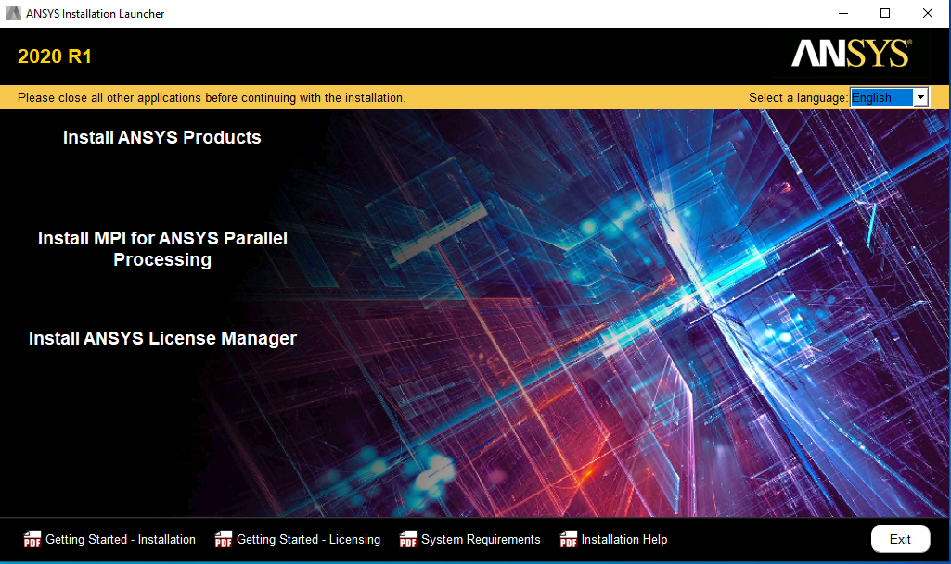

1. Select “I Agree “ and Click on the “Next” button.

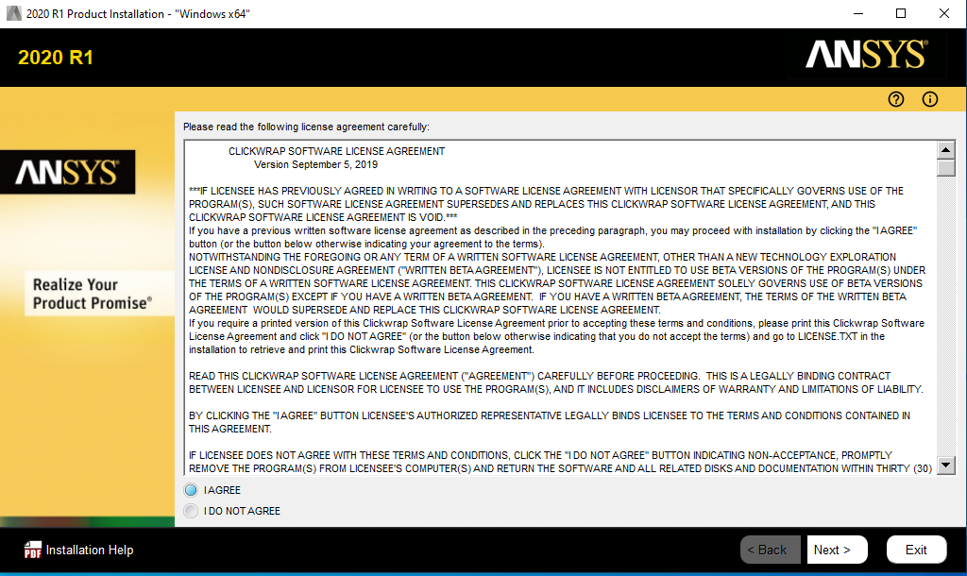

1. Click on the “Next” button.

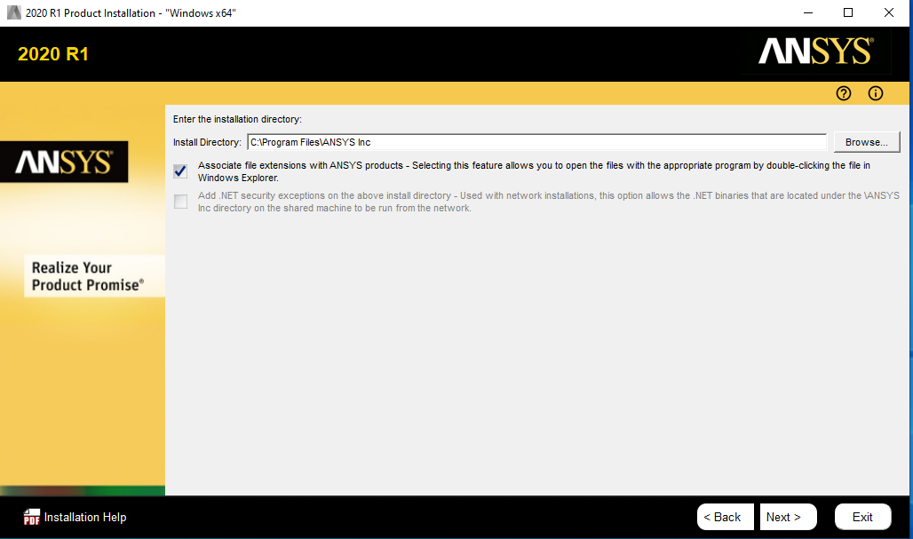

1. Enter Ansys License Server IP Add in “Hostname”. (Network Linence Server for IIT Campus is “akash3.cc.iitk.ac.in”) and Click on “OK” Button.

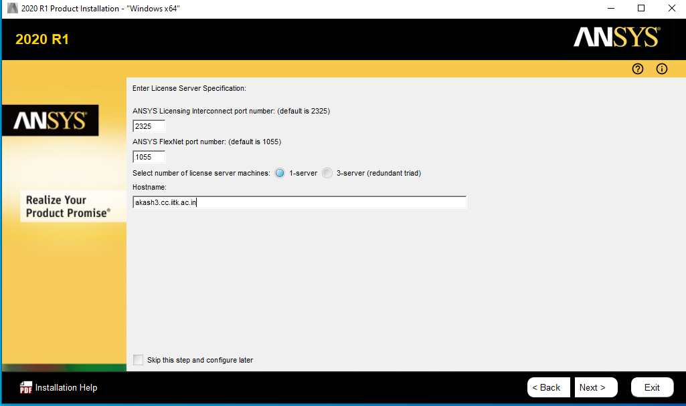

1. Select the required products (Default Recommended) and Click on the “Next” button.

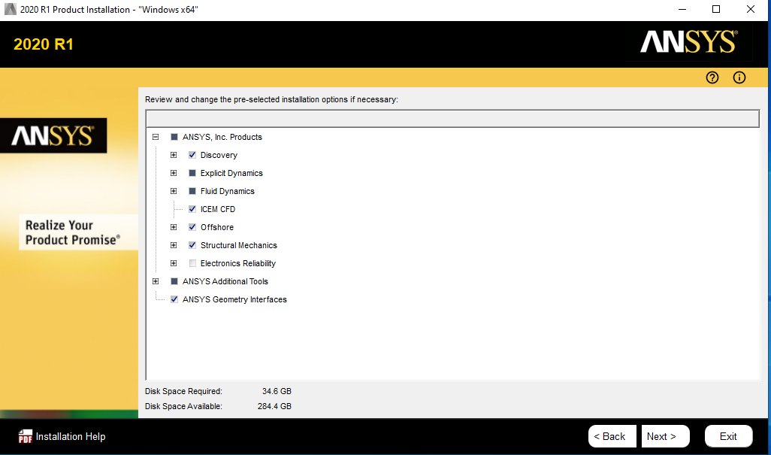

1. Select “Yes, automatically configure my interfaces” and click on the “Next” button.

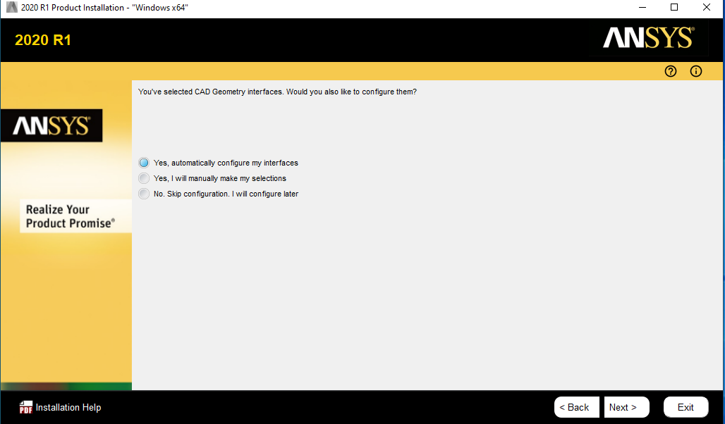

1. Click on the “Next” button.

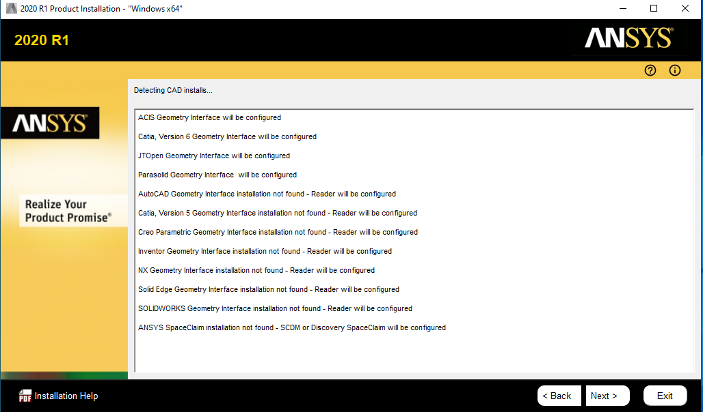

1. Click on the “Next” button.

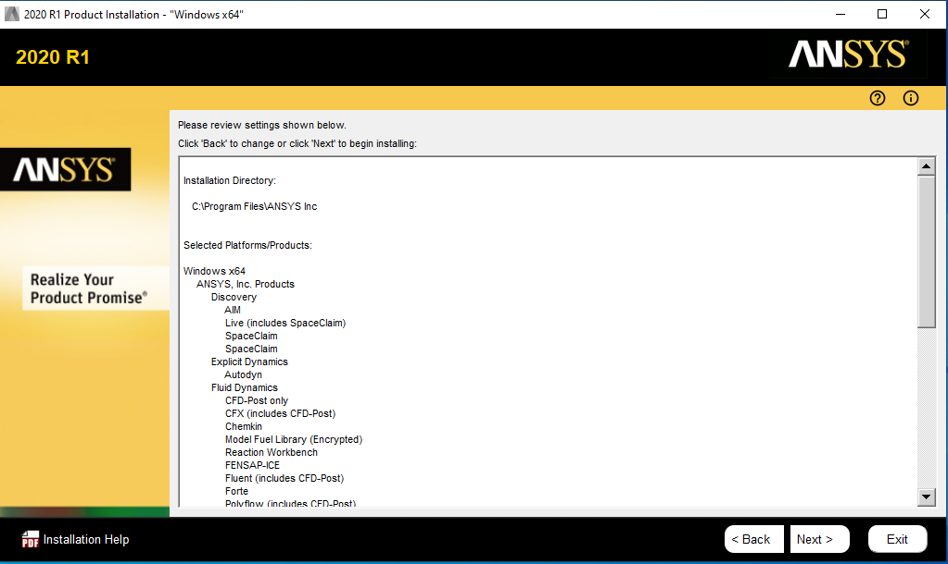

1. Wait for several minutes Ansys 2020 installation to complete and click on the “Next” button.

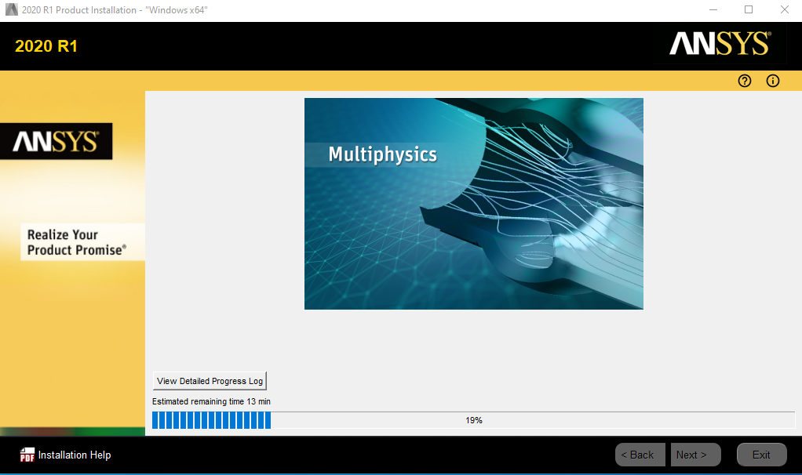

1. Uncheck “Launch survey upon exiting” and click “Exit” button.

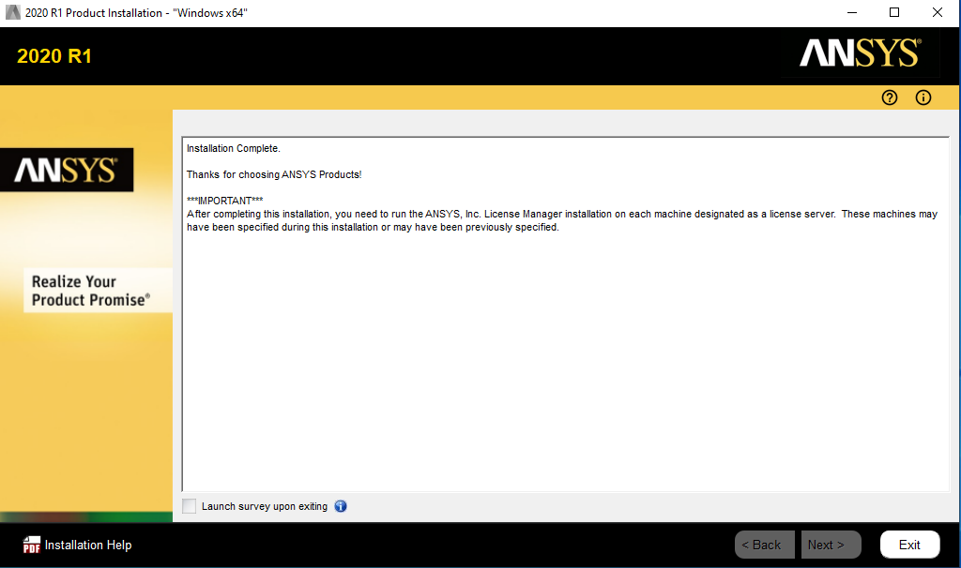

1. Open “ClientANSLIC_ADMIN Utility” from the START menu and click on “Specify the License Server Machine”.

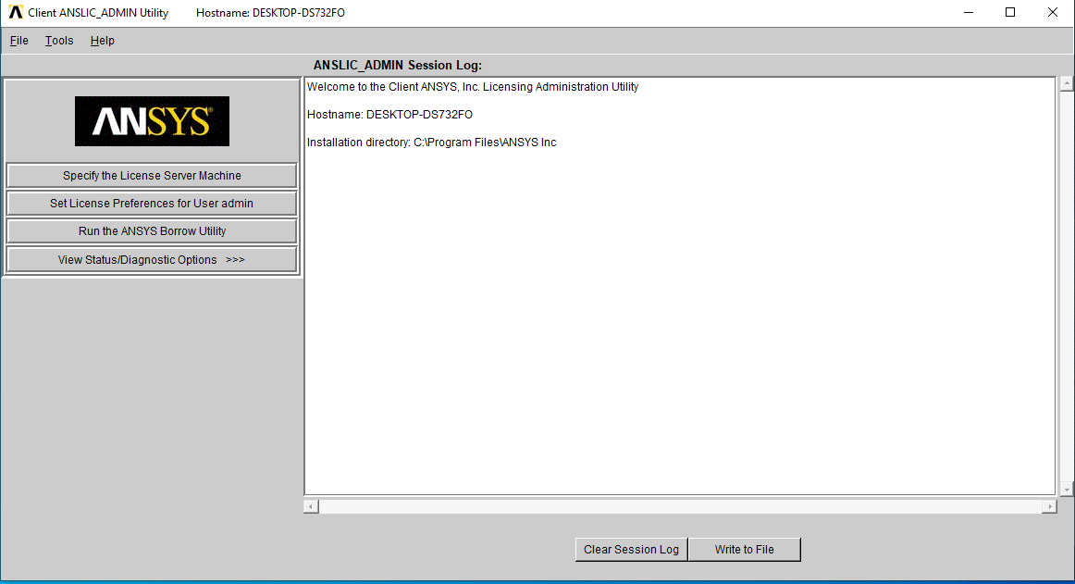

1. Show ANSYS Licensing Interconnected and ANSYS FLEXIm server machine Specified .

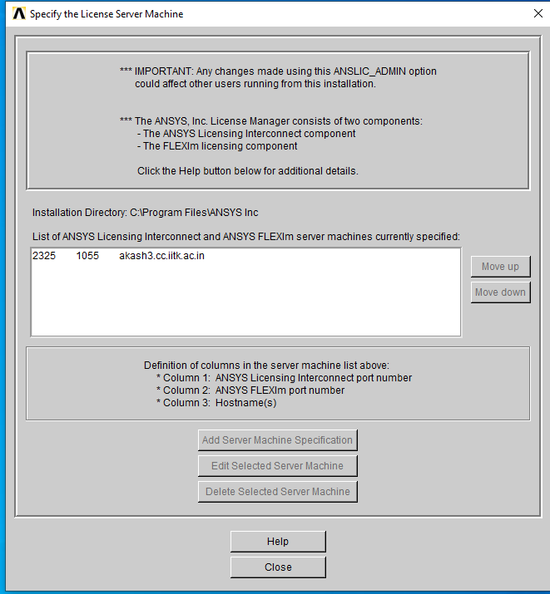

1. The previews of software as Below:

